**CE101 Engineering Drawing July- Nov 2019**

**Indian Institute of Technology Guwahati**

**Lab Sheet-10 Isometric Projections Monday Morning**

**Max Marks: 80 Date: 28.10.2019**

**Q. 1 Following figure shows orthographic views of an object. Draw its ISOMETRIC PROJECTION. [15 marks]**

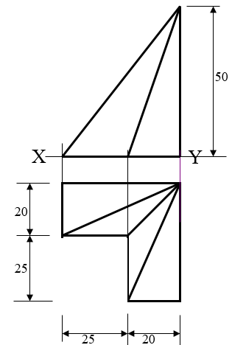

**Q. 2 Following figure shows orthographic views of an object. Draw its ISOMETRIC VIEW. [15 marks]**

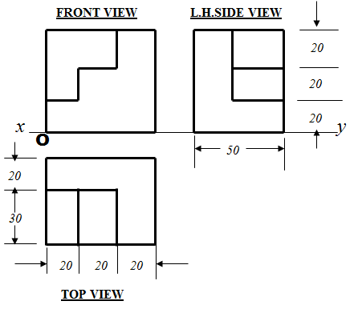

**Q.3 Following figure shows orthographic views of an object. Draw its ISOMETRIC VIEW. [25 marks]**

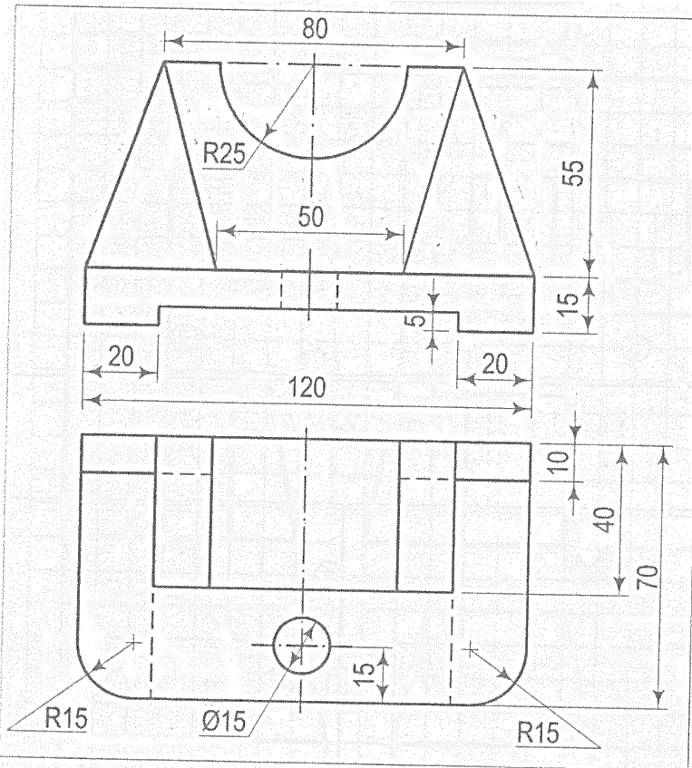

**Q.4 Following figure shows orthographic views of an object. Draw its ISOMETRIC VIEW. [25 marks]**

